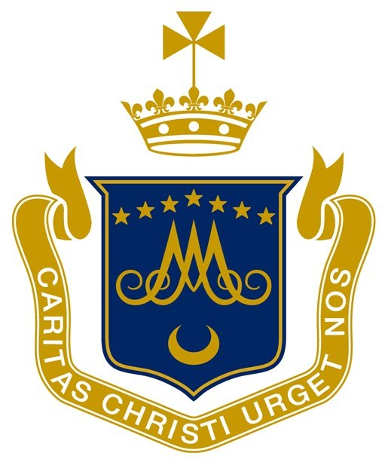 | SCOIL MHUIRE GNS  Gilford Rd, Sandymount, Dublin 4, D04 DC04  Ph: 01 269 5273  Email: office@scoilmhuiregns.ie

ANNUAL ADMISSION NOTICE
In respect of admissions to the 2021/2022 school year

A copy of the school’s Admission Policy and the Application Form for Admission for the 2021/2022 school year is available as follows:

To download at: www.scoilmhuiregns.ie

On request by: Emailing office@scoilmhuiregns.ie
or writing to Scoil Mhuire GNS, Gilford Road, Sandymount, Dublin 4, D04 DC04.

Admissions to the 2021/2022 school year

Application and Decision Dates for admission to 2021/2022

The following are the dates applicable for admission to Junior Infants

The school will commence accepting applications for admission on: | 3rd November, 2020
The school shall cease accepting applications for admission on: | 25th November, 2020
The date by which applicants will be notified of the decision on their application is: | 9th December, 2020
The period within which applicants must confirm acceptance of an offer of admission is: | From 9th to 18th December, 2020

*Failure to accept an offer within the prescribed period above will result in the offer being forfeited.

Note: the school will consider and issue decisions on late applications in accordance with the school’s Admission Policy.

The number of places being made available in Junior Infants | 56

