Singing Classes
Details:
Singing classes for 2nd-6th Class students
Thursday afternoons with Ms Muireann Mulrooney (scroll down for biography).
Concert performance at Christmas.
Small groups-max 7 per group
Limited places -first come, first served basis
€180 per 12 week term

Please contact m.mulrooney@scoilmhuiregns.ie for more details

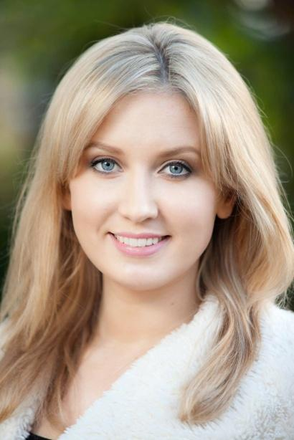
Muireann Mulrooney~Biography
Kilkenny native, Muireann Mulrooney studied at the Kilkenny School of Music before reading Education, Music and English at Dublin City University. Muireann subsequently graduated from TUD (formerly DIT Conservatory of Music and Drama). She holds a Bachelor of Music in Performance degree and a Masters of Music in Performance. During her time at the conservatory, Muireann won first prize in the La Scala Competition, a scholarship to the Yorke Trust and performed on numerous occasions on behalf of the college in the Hugh Lane Gallery and the National Concert Hall. Muireann is also an alumnus of the prestigious Opera Works programme at English National Opera, London.
Muireann has performed for Irish National Opera, Opera Theatre Company, Lyric Opera, Northern Ireland Opera, Wide Open Opera, Loughcrew Garden Opera and English National Opera in venues such as the National Concert Hall, the Gaiety Theatre, Wexford Opera House, the Bord Gáis Energy Theatre, the Southbank Centre and the Barbican. Opera roles include the Countess Almaviva Le Nozze di Figaro; Papagena The Magic Flute; La Princesse L’Enfants et les sortilèges and Annina La Traviata with the RTÉ Concert Orchestra. Muireann has performed in numerous productions including Madama Butterfly, Aida, Nixon in China, Macbeth and the Fedora Prize winning contemporary opera The Second Violinist, directed by Enda Walsh at the Muziekgebouw aan ‘t IJ, Amsterdam. Most recently, she recorded with Irish National Opera Strauss’ Elektra, Mozart’s Die Entführung aus dem Serail and Puccini’s La Bohème.
Oratorio works include Fauré’s Requiem in Christ Church Cathedral with the Enchiriadis Treis choir and Dublin Orchestral Players and Vaughan William’s Mass in g minor in St. Patrick’s Cathedral with the Guinness Choir.
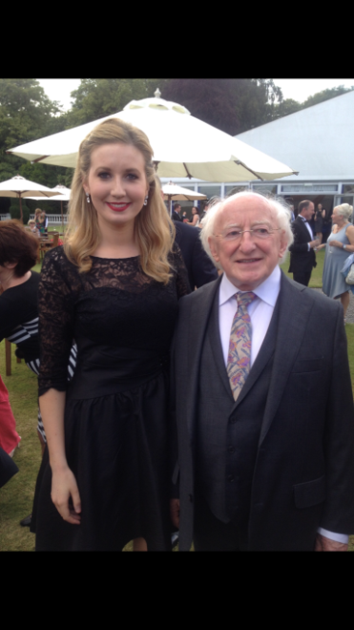
Muireann has also performed on RTÉ’s The Late Late Show, BBC, Lyric FM radio and with the original and highly successful Opera Singing Waiters-winners of the Corporate Entertainment of the Year Awards at the Event Industry Awards. She has performed many times for our President Michael D. Higgins on stage and in Áras an Uachtarain.
Over the years, Muireann has gotten tremendous enjoyment out of teaching children and adults to sing for pleasure and to achieve their own individual goals. She has coached students to prepare for examinations with the Royal Irish Academy of Music, The Associated Board of the Royal Schools and Music and the Junior and Leaving Certificate exams.

